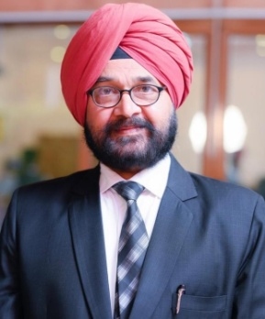

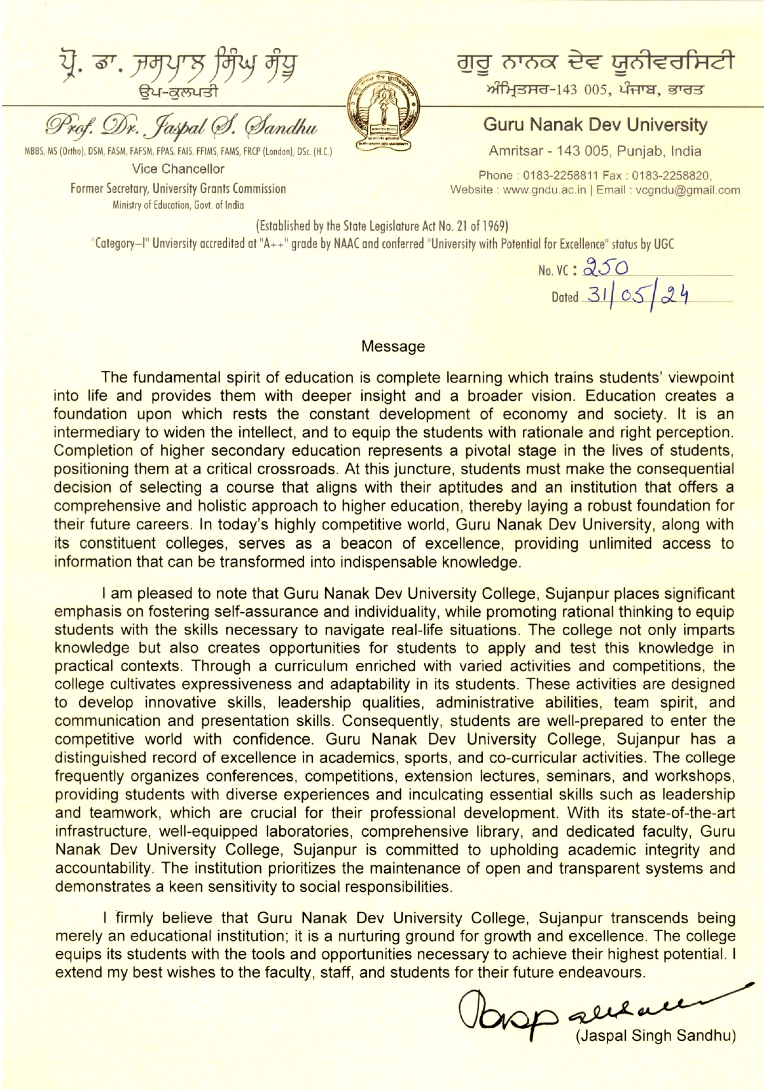

Page No. 3

Message

The fundamental spirit of education is complete learning which trains students' viewpoint into life and provides them with deeper insight and a broader vision. Education creates a foundation upon which rests the constant development of economy and society. It is an intermediary to widen the intellect, and to equip the students with rationale and right perception. Completion of higher secondary education represents a pivotal stage in the lives of students, positioning them at a critical crossroads. At this juncture, students must make the consequential decision of selecting a course that aligns with their aptitudes and an institution that offers a comprehensive and holistic approach to higher education, thereby laying a robust foundation for their future careers. In today's highly competitive world, Guru Nanak Dev University, along with its constituent colleges, serves as a beacon of excellence, providing unlimited access to information that can be transformed into indispensable knowledge.

I am pleased to note that Guru Nanak Dev University College, Sujanpur places significant emphasis on fostering self-assurance and individuality, while promoting rational thinking to equip students with the skills necessary to navigate real-life situations. The college not only imparts knowledge but also creates opportunities for students to apply and test this knowledge in practical contexts. Through a curriculum enriched with varied activities and competitions, the college cultivates expressiveness and adaptability in its students. These activities are designed to develop innovative skills, leadership qualities, administrative abilities, team spirit, and communication and presentation skills. Consequently, students are well-prepared to enter the competitive world with confidence. Guru Nanak Dev University College, Sujanpur has a distinguished record of excellence in academics, sports, and co-curricular activities. The college frequently organizes conferences, competitions, extension lectures, seminars, and workshops, providing students with diverse experiences and inculcating essential skills such as leadership and teamwork, which are crucial for their professional development. With its state-of-the-art infrastructure, well-equipped laboratories, comprehensive library, and dedicated faculty, Guru Nanak Dev University College, Sujanpur is committed to upholding academic integrity and accountability. The institution prioritizes the maintenance of open and transparent systems and demonstrates a keen sensitivity to social responsibilities.

I firmly believe that Guru Nanak Dev University College, Sujanpur transcends being merely an educational institution; it is a nurturing ground for growth and excellence. The college equips its students with the tools and opportunities necessary to achieve their highest potential. I extend my best wishes to the faculty, staff, and students for their future endeavours.

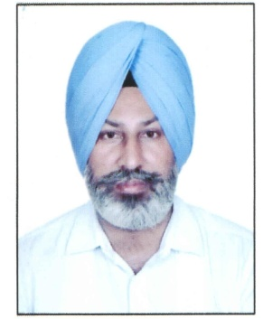

MESSAGE

Guru Nanak Dev University, Amritsar, accredited with "A++" grade by the NAAC, conferred with "Category One" status and "University with Potential for Excellence" by the University Grants Commission, Ministry of Human Resource Development, Government of India always endeavours to become an Institution of Excellence in academics, research, sports and cultural activities persistently heading towards fulfilling the ultimate aim of illuminating and enlightening the young minds by the way of providing them with latest educational platforms and opportunities. It is a matter of pride that on account of adopting sustainable environmental practices and green initiatives, the University has been ranked second amongst the cleanest higher educational institutions in the country in the category of Government Universities by the Ministry of Human Resource Development, Government of India.

In order to keep pace with the contemporary times and meet the demands of industry and employment generation, the University is continuously upgrading its academic programmes and syllabi.

I am pleased to note that Guru Nanak Dev University, College, Suajnpur is bringing out the issue of Prospectus for the academic session 2024-25. The college has privilege of having a peaceful, natural and conducive environment for studies, with the prime objectives to provide value-based quality education and career oriented programs to the students and make them employable. I am sure, the courses offered by the College will transform our young students into achievers in a real world.

I welcome all the students and wish you all the best for your future endeavours for achieving greater success. Undoubtedly, your concerted efforts with the able guidance of your teachers would definitely provide you a blissful and successful life.

Prof. (Dr.) Palwinder Singh

Dean Academic Affairs

Guru Nanak Dev University, Amritsar



Prospectus for Session 2024-2025

Guru Nanak Dev University College, Sujanpur

Message

It gives me immense pleasure to know that Guru Nanak Dev University College, Sujanpur is

publishing the Prospectus for the session 2024-2025.

Guru Nanak Dev University College, Sujanpur was established in 2016 under Guru Nanak Dev University, Amritsar with the prime objectives to provide qualitative education and career oriented programs. It is one of the constituent colleges established with the united efforts of the University Grants Commission, New Delhi, Punjab Government and Guru Nanak Dev University, Amritsar. It is an institution with a sprawling campus and it is the most renowned institute in Pathankot District. The college provides pleasant, natural and a healthy learning environment. Students get suitable conducive academic atmosphere for their studies. Our mission is to transform students into rational thinkers, competent workers, law abiding citizen and spiritually enlightened individuals. The college has the privilege of having a healthy, harmonious ambience and the rich values which have played pivotal role in shaping the future of students.

The college provides an effective platform to the students in different cultural activities like music, drama, theater and dance in the youth festival & in other activities. I believe that you would develop versatile personality during your stay in this temple of learning. To be successful in life, having ambitions and defining your goals clearly. Your concerted efforts with the able guidance of your teachers would definitely provide you a blissful and a successful life. I am sure under the dynamic leadership of Principal, the college will touch new heights in the coming years.

I, welcome all the students and wishes all the best for achieving greater parameters of success

and scaling new heights in the coming session.

Registrar



It is a privilege to lead as head of Constituent colleges associated with Guru Nanak Dev University, Amritsar. These colleges have been established as a result of united effort of UGC, Government of Punjab and Guru Nanak Dev University, Amritsar with special purposes of raising the standard of higher education specially in rural area. These constituent colleges are under GNDU Management and get financial support from Punjab Government for that reason, the fee structure has been according to the government colleges. These colleges provide quality and affordable education to needy students.

While cherishing the journey and milestones achieved so far, we must look forward and prepare ourselves for future challenges to propel these colleges to even greater heights. From current year (2024-25), our primary focus is on implementing the New Education Policy (NEP) in its true spirit, fostering inter-disciplinary research, deepening industry-academia collaboration, exploring and developing new avenues of knowledge, and resource generation through knowledge transfer. The students spend a significant portion of their lives on campus. They join the colleges to make their dreams a reality. In a world where change is the only constant, the colleges provide the students a solid foundation for their careers. The colleges give them the opportunity to integrate their minds, imaginations, and emotions in order to become capable of resolving public issues. The students have twofold responsibilities: one is to transform themselves, and the other is to address the complex problems faced by the society. It is my earnest appeal to students to make the best use of the time they spend at the college for their holistic transformation. The students must keep their curiosity alive and experiment new things. Let us educate society so that it is capable of generating innumerable ideas for human welfare. I am hopeful and confident that with everyone's support and commitment, we will achieve new milestones with ever- rising benchmarks, help our youth in making their dreams a reality, and propel the colleges to new heights. I urge the students to choose these colleges as their first preference.

The credit also goes to Vice-Chancellor of University, who has put in great efforts to establish and develop these colleges.

Dean CDC

Prof. (Dr.) Saroj Bala

**From OSD’s Desk**



While I welcome you all to holy precincts of our institution named Guru Nanak Dev University College Sujanpur, I, along with all faculty members, am excited to meet you one by one our mutual enrichment.

Having spent more than 45 years in the field of Higher Education, I have come to realize the value of collaboration, compassion, and consideration for everyone under the sky and on the earth. Teaching and learning go side by side and we are all duty bound to hold each other’s hands making our institution a much sought after centre of learning.

Yet another thought comes to my mind. It pertains to the current unbearable heat of the scorching sun. To this issue, we need to rise up for making eco-friendly activity a part of our day-to-day routine.

Let us begin by planting more and more trees, entering the domain of paperless communication, and by promoting flora and fauna around us.

You are welcome any time and every time to meet me in my office.

OSD/Principal,

GNDU College, Sujanpur

**New Education Policy Introduced**

**Note: Detailed Policy can be obtained from the college office.**

Appendix - C

**4-year UG Honours Degree Programmes under NEP 2020**

**(w.e.f. session 2024-25)**

The Guru Nanak Dev University, Amritsar has introduced 4-year under graduate Honours Degree Programmes as per NEP 2020 in all the affiliated colleges/ constituent colleges from the academic year 2024-25. The University has developed the curricular framework for Honours programmes incorporating a credit-based grading system, a multidisciplinary approach, with specialization in a single discipline specific course in the 4th year of the program.

This policy mandates compliance with the curricular framework and standard operating procedures outlined herein. Compliance with these procedures is mandatory for all the colleges.

The curriculum framework for 4-year UG Degree Programmes has the following features:

1. **Discipline Specific Courses:** Discipline Specific Courses (DSC) are designed to provide in depth knowledge and skills pertinent to a particular field or profession. These courses focus on specialized content and methodologies tailored to the needs of students pursuing carrier in that discipline. These courses are integral to build a solid foundation in the respective fields and often involve both theoretical study and practical application through labs, projects, internship etc.

Each student is required to select and successfully complete three DSCs as part of first 3 years of their undergraduate degree program. In the 4th year of undergraduate honours degree programme, students have the option to choose any one of the Discipline Specific Courses (DSC) that they have studied during the first three years of their undergraduate degree programme.

2. **Ability Enhancement Courses:** Ability Enhancement Courses (AEC) are designed to develop essential skills and competencies that complement the student's major field of study, enhancing their overall educational experience and employability. Each student is required to successfully complete at least one AEC every year during first three years of undergraduate degree program.

3. **Multidisciplinary Courses:** Multidisciplinary Courses (MDC) are designed to integrate knowledge and methodologies from multiple disciplines, providing student with a holistic understanding of complex issues and fostering innovation thinking. Each student is required to select and successfully complete at least one MDC every year during first 3 years of undergraduate degree program.

4. **Skill Enhancement Courses:** Skill Enhancement Courses (SEC) are designed to develop specific skills that are valuable for personal growth, academic excellence, and carrier readiness. Each student is required to select and successfully complete at least one SEC every year during first 3 years undergraduate degree program.

5. **Value Added Courses:** Value Added Courses (VAC) are designed to provide students with specialized knowledge and understanding in critical areas that are relevant to societal and environmental challenges.

Value added courses viz Drug Abuse: problem management and prevention, Environmental Studies, and Human Rights & Constitutional Duties are mandatory qualifying courses for a student of an undergraduate degree program. Students is required to successfully complete all the three VACs during first 3 years of undergraduate degree programme.

**Standard Operating Procedures**

Entry and Exit options for Students of 4-year UG Degree Programme with Honours:

**Entry 1: 1st year (1st Sem.):**

• The entry requirement for the 1st year of 4-year UG Degree is Intermediate /12th class of PSEB/CBSE/ or any other equivalent certificate and as per the eligibility conditions as specified in the Ordinances related to respective stream/ programme.

**Entry 2: 4th year (VIIth Sem.):**

• A student who has completed a three-year degree program with three discipline specific subjects (majors) may enter in the 4th year (VIlth Sem) of Honours programme in any one of the three discipline specific subjects (major) studied in the first three years of the UG Degree Programme.

**Note:** Students who complete the first three years in a college shall be automatically promoted to the 4th year within the same college, without any new admissions provided the student must fulfil all eligibility and promotion criteria as stipulated in CBGS Ordinances.

**Exit 1: after 3-years (6 sem.):**

• Students must pass all courses/papers in Semesters 1 to 6 if they wish to exit after three years with a normal UG Degree.

• A Bachelor's Degree is to be awarded if students exit after successful completion of 3-year of study.

**Exit 2: after 4-years (8 sem.):**

• A Bachelor's Degree with Honours is to be awarded if students exit after successful completion of 4 year of study.

**Note:** Rest of the Ordinances will be as per Credit Based Grading System (CBGS) for Affiliated/Constituent/ University Colleges/Capacity Enhancement Programme/ Private Candidates, and will be in accordance with the University Calendars or as stipulated in the ordinances of the respective stream/ programme unless otherwise specified.